**Bayer Low Tunnel Volatility Study**

Summary of 20-ARL-SB23 study

*Rodrigo Werle1, Ryan DeWerff 2, Nick Arneson3, Sarah Striegel 4, Nikola Arsenijevic5, Felipe Faleco5, Kolby Grint5, Haleigh Ortmeier-Clarke5, Jose Nunes6 and Emily Glaeser 7*

*1 Principal Investigator, 2 Research Technician, 3 Outreach Research and Extension Associate, 4 Former Graduate Student, 5 Graduate Student, 6 Visiting Scholar,*

*7 Undergraduate Research Assistant*

Questions on the contents of this report should be directed to Rodrigo Werle (rwerle@wisc.edu) and Sarah Striegel (sstriegel@wisc.edu).

**

**Contents**

Methods...................................................................................................................................... 5

Results......................................................................................................................................... 7

**List of Figures**

Figure 1. Nontreated Check at 28 DAT............................................................................... 12

Figure 2. MON 76980 + MON 79789 + MON 301656 at 28 DAT............................... 13

Figure 3. MON 76980 + MON 79789 + MON 301656 + MON 51817 – VaporGrip

at 28 DAT................................................................................................................................. 14

Figure 4. MON 301822 + MON 79789 at 28 DAT........................................................... 15

Figure 5. MON 301859 + MON 79789 at 28 DAT........................................................... 16

Figure 6. MON 301621 at 28 DAT....................................................................................... 17

Figure 7. MON 301848 at 28 DAT....................................................................................... 18

Figure 8. MON 301848 + MON 51817 – VaporGrip at 28 DAT................................... 19

**List of Tables**

Table 1. Weather conditions in the 48 h period of flat placement under the low tunnels at the University of Wisconsin-Madison Arlington Agriculture Research

Station........................................................................................................................................ 6

Table 2. Sum of soybean stand count, sum of injured plants and the % of injured soybean plants 14 and 28 days after treatment in the three replications within 25 ft quadrant at the University of Wisconsin-Madison Arlington Agriculture Research

Station....................................................................................................................................... 11

**Methods**

* Soybean variety: CZ 1549GTLL
* Soybean seeding rate: 140,000 seeds ac-1 at 1.5” depth
* Soybean row width: 30” row width
* Soybean planting date: June 15
* Plot maintenance:
* PRE herbicide treatment – June 15, 2 pts ac-1 Prefix + 22 fl oz ac-1 Roundup PowerMax + 8.5 lbs AMS/100 gal
* POST herbicide treatment – July 1, 22 fl oz ac-1 Roundup PowerMax + 8.5 lbs AMS/100 gal
* Herbicide treatment (flats): 9:00 to 9:30 am July 13
* Soybean stage at flat application: V4
* Flat removal from low-tunnel: 3:45 to 5 pm July 14
* Results presented at 14 and 28 days after treatment (DAT) for the 25-ft quadrant with the most severe and consistent injury
* Photos taken at 28 DAT

Table 1. Weather conditions in the 48 h period of flat placement under the low tunnels at the University of Wisconsin-Madison Arlington Agriculture Research Station.

|  |  |  |  |  |  |  |  |  |  |  |  |  |  |  |  |  |
| --- | --- | --- | --- | --- | --- | --- | --- | --- | --- | --- | --- | --- | --- | --- | --- | --- |
| Date | Soil flat temp (F) | | | Air temp (6 in, F) | | | Air temp (27 in, F) | | | Relative humidity (%) | | | Air temp (39 in, F) | | | Rainfall (in) |
| Avg | Max | Min | Avg | Max | Min | Avg | Max | Min | Avg | Max | Min | Avg | Max | Min |
| 0-24 h | 79.2 | 103.8 | 65.3 | 75.4 | 92.7 | 63.9 | 74.1 | 90.3 | 64.0 | 75.4 | 94.5 | 49.3 | 72.2 | 83.2 | 63.7 | 0.4 |
| 24-48 h | 84.4 | 93.3 | 76.6 | 80.1 | 86.6 | 74.1 | 78.7 | 83.6 | 74.0 | 65.5 | 71.9 | 61.0 | 77.9 | 82.0 | 73.7 | 0.0 |

**Results**

****Source: University of Wisconsin-Madison Cropping Systems Weed Science, 2020



Source: University of Wisconsin-Madison Cropping Systems Weed Science, 2020



Source: University of Wisconsin-Madison Cropping Systems Weed Science, 2020



Source: University of Wisconsin-Madison Cropping Systems Weed Science, 2020

Table 2. Sum of soybean stand count, sum of injured plants and the % of injured soybean plants 14 and 28 days after treatment in the three replications within 25 ft quadrant at the University of Wisconsin-Madison Arlington Agriculture Research Station.

|  |  |  |  |  |  |
| --- | --- | --- | --- | --- | --- |
| Treatment | Stand count | Injured plants | | %, Injured plants | |
| 14 | 28 | 14 | 28 |
| Nontreated Check | 157 | 0 | 0 | 0 | 0.0 |
| MON 76980 + MON 79789 + MON 301656 | 169 | 4 | 8 | 2.4 | 4.5 |
| MON 76980 + MON 79789 + MON 301656 + MON 51817 – VaporGrip | 159 | 2 | 0 | 1.4 | 0.0 |
| MON 301822 + MON 79789 | 179 | 1 | 0 | 0.8 | 0.0 |
| MON 301859 + MON 79789 | 178 | 4 | 3 | 2.5 | 1.6 |
| MON 301621 | 151 | 50 | 49 | 32.8 | 32.4 |
| MON 301848 | 171 | 59 | 61 | 34.5 | 35.8 |
| MON 301848 + MON 51817 - VaporGrip | 166 | 7 | 3 | 4.4 | 1.5 |

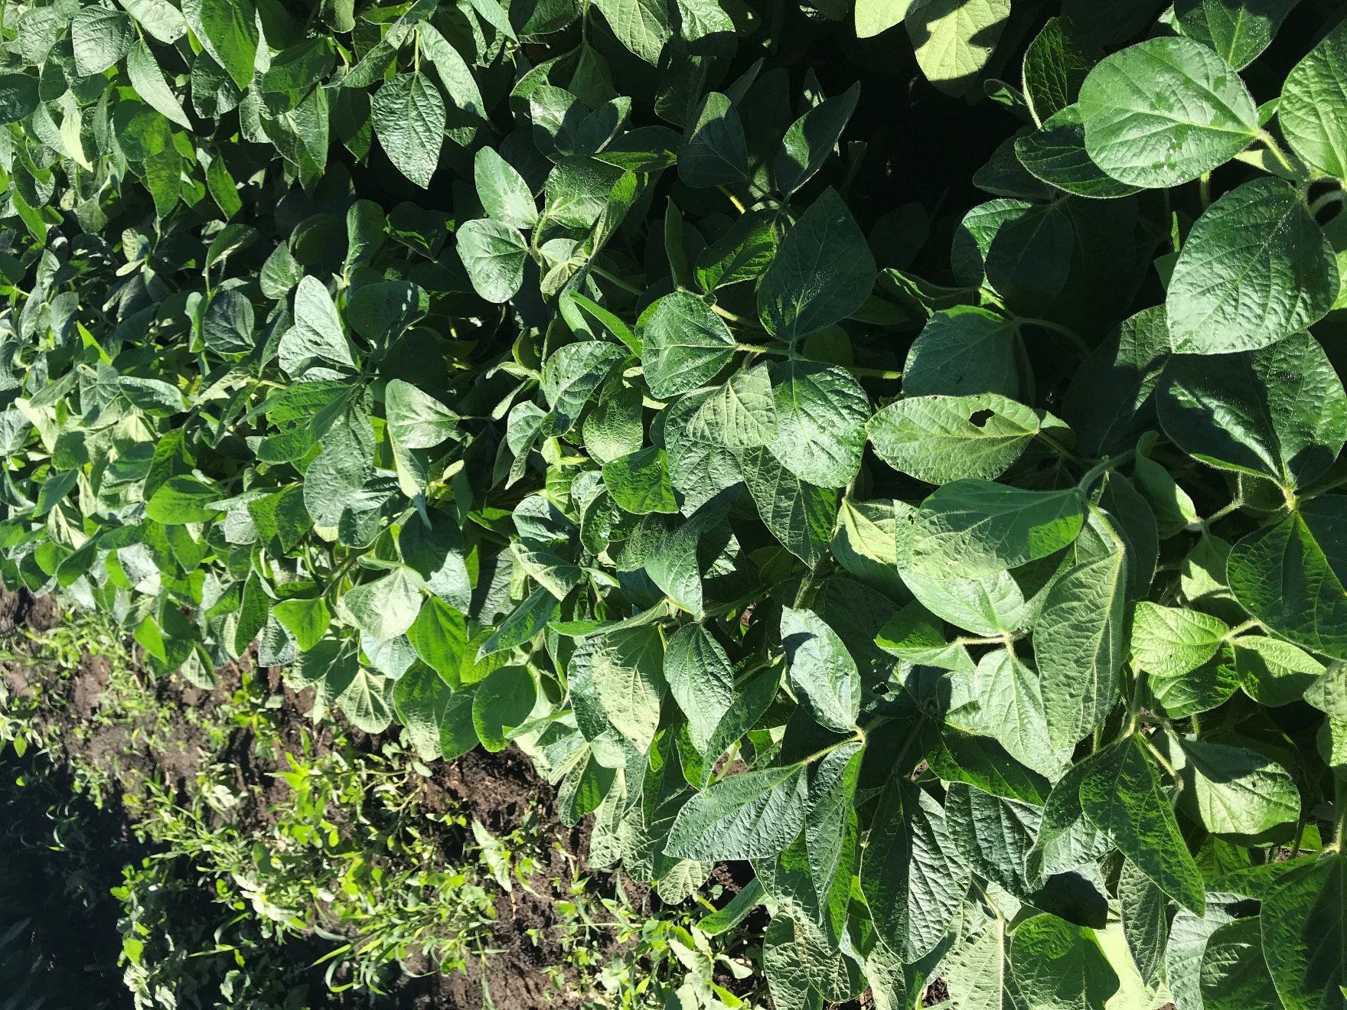

Figure 1. Nontreated Check at 28 DAT.

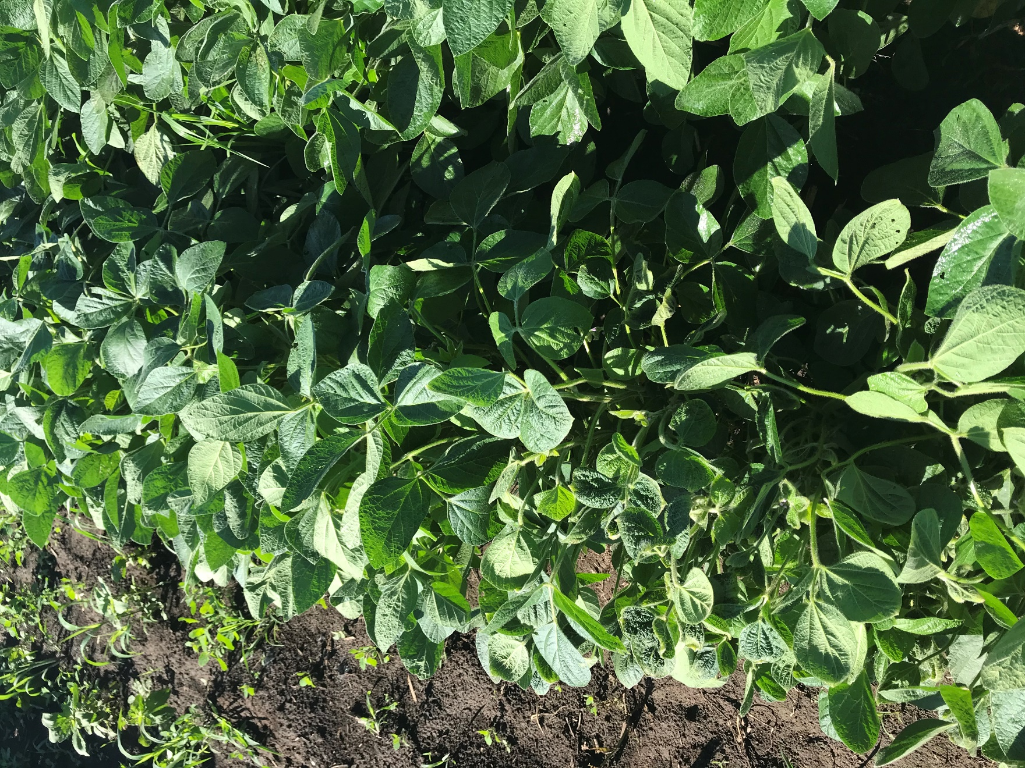

Figure 2. MON 76980 + MON 79789 + MON 301656 at 28 DAT.

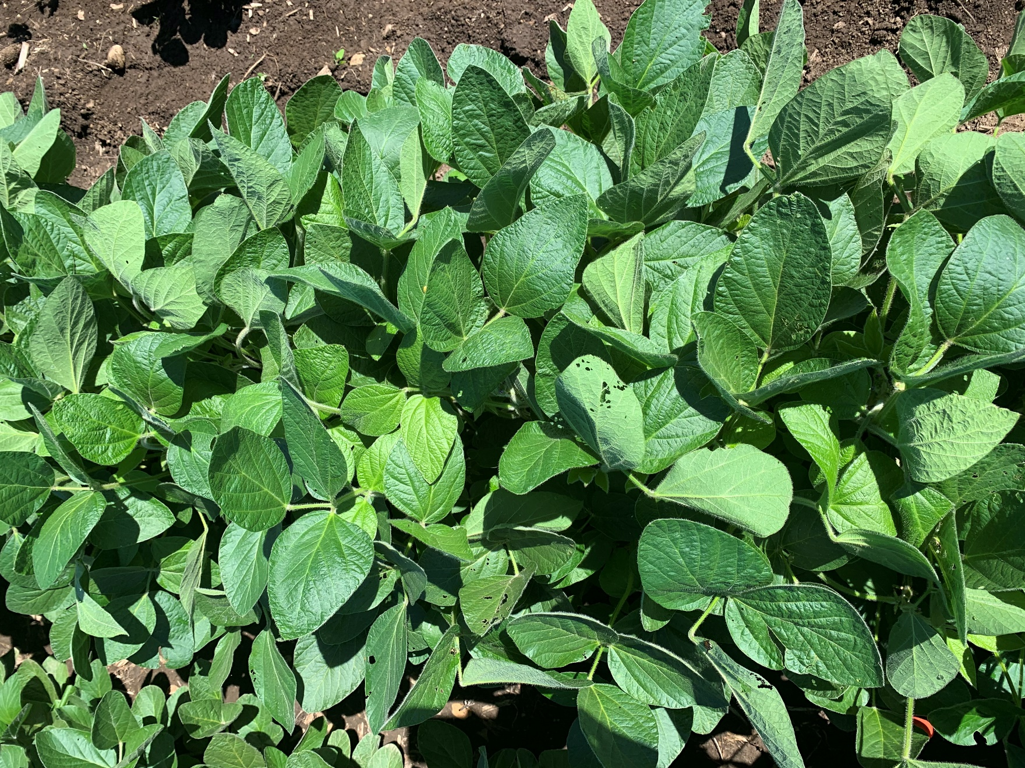

Figure 3. MON 76980 + MON 79789 + MON 301656 + MON 51817 – VaporGrip at 28 DAT.

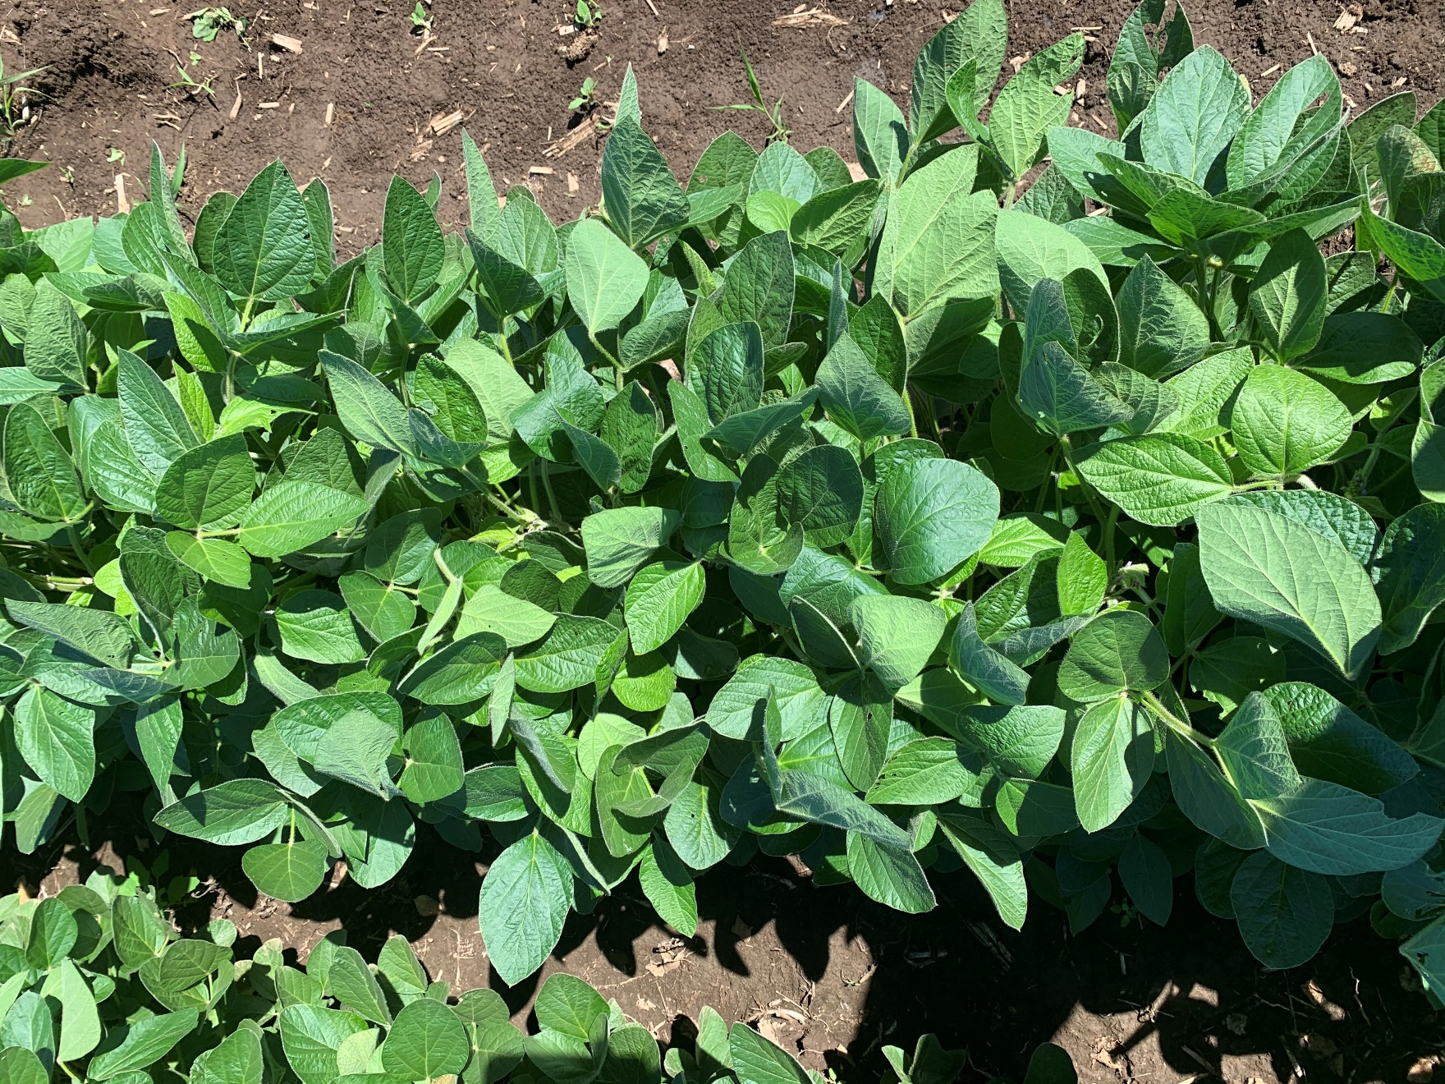

Figure 4. MON 301822 + MON 79789 at 28 DAT.

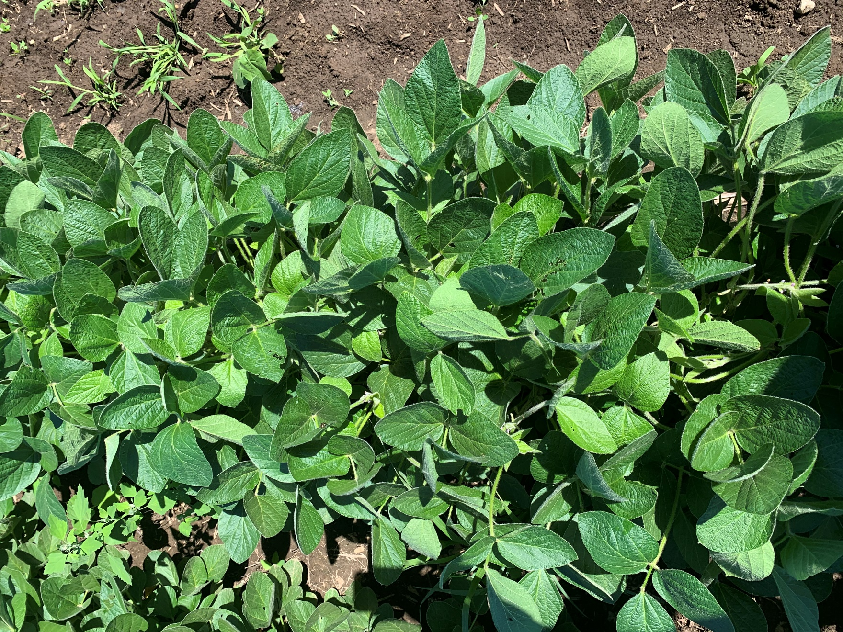

Figure 5. MON 301859 + MON 79789 at 28 DAT.

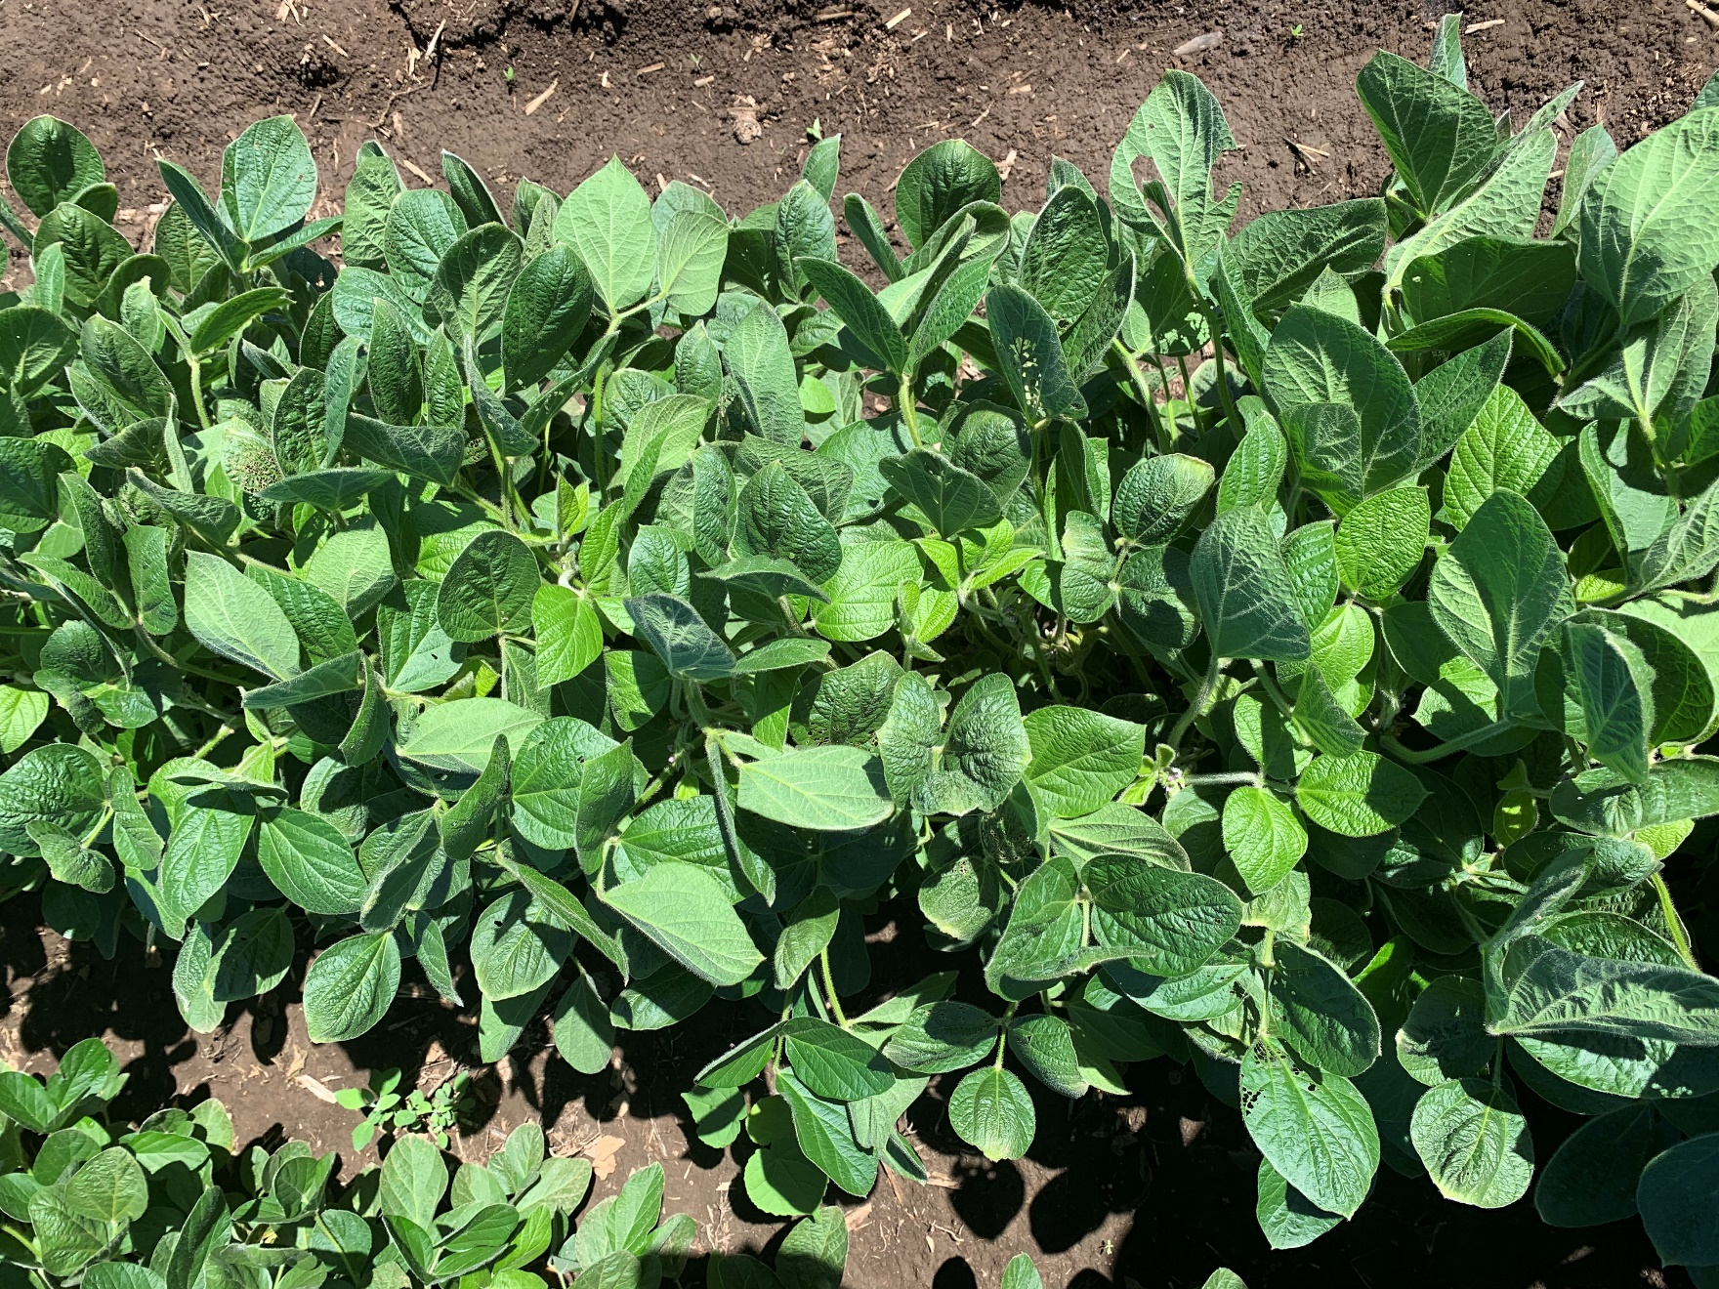

Figure 6. MON 301621 at 28 DAT.

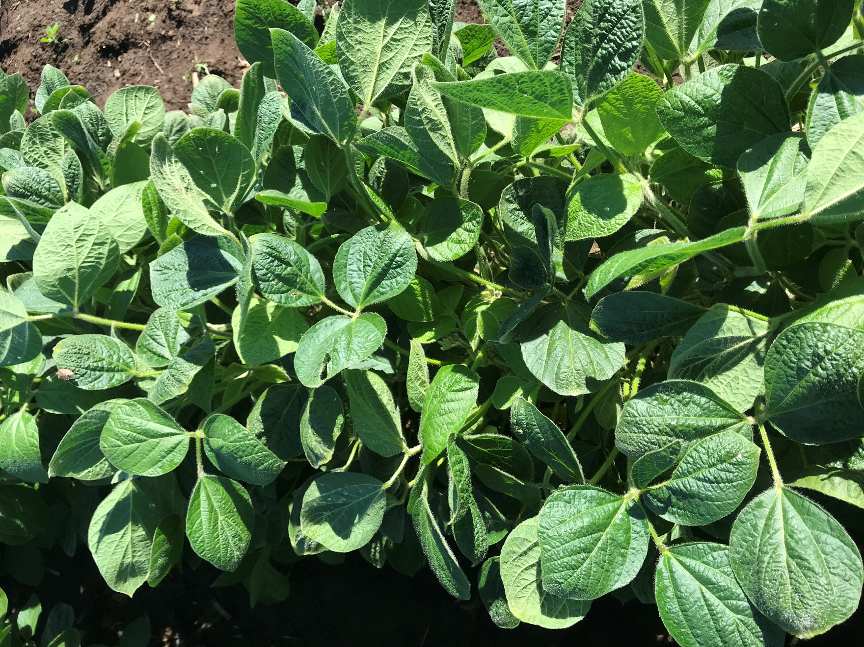

Figure 7. MON 301848 at 28 DAT.

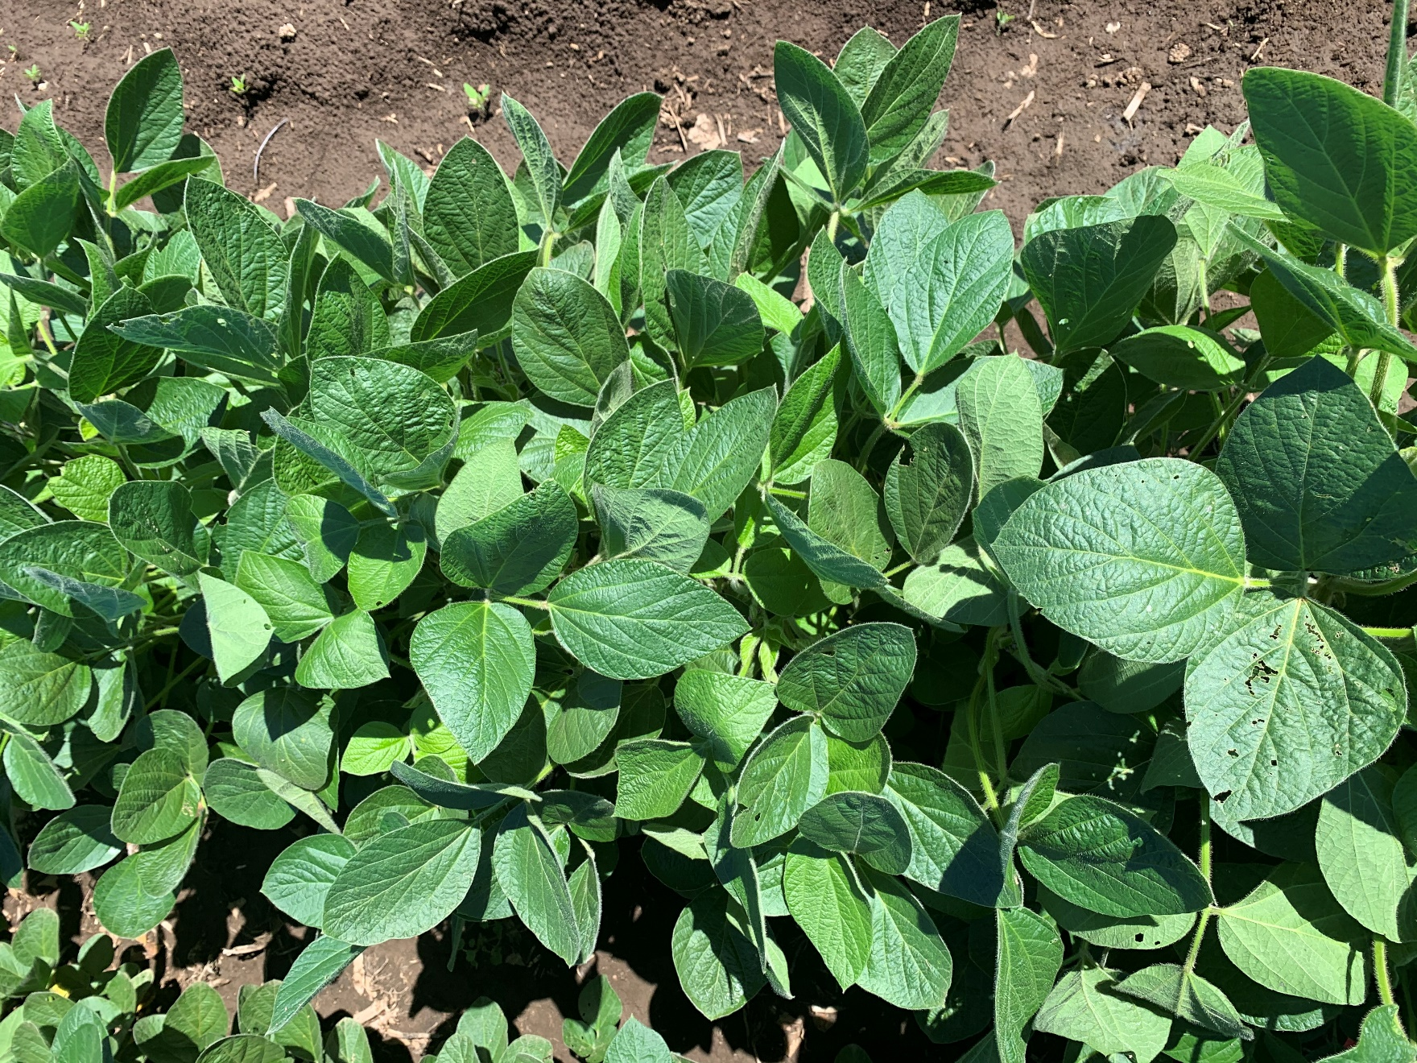

Figure 8. MON 301848 + MON 51817 – VaporGrip at 28 DAT.